Report:

Title: Strains in a Ring under Combined Bending and Extension

1. **Objective**
2. To measure strains using bonded foil strain gauges in combination with a Wheatstone Bridge.
3. Compare with linear elastic solution in a “proving” ring (circular beam with rectangular cross-section) subjected to combined extension and bending with strains measured from experiment.
4. **Experimental Method(s):**
5. Mounted on a fixture is an aluminium ring with a Young's modulus of 70GPa, an inner diameter of 129.6 mm, a thickness of 14.8 mm, and a depth of 11.2 mm.
6. A device that uses the balanced wheat-stone bridge principle to show values of the measured strain.
7. Before starting the measurements, balance the wheat-stone bridge.
8. Auto balance the device if not then follow the instructions given on the device to manually balance the device.
9. Note the strain values at various loads.
10. Take the initial reading of zero weight added, but there is a 0.5 kg inaccuracy because the hanger weighs 500 g, thus the device is not actually set to zero..
11. Continue to add 1 kg of weight after that and record the strain values at the four gauges in the case of loading.
12. Remove each weight until there is nothing left on the hanger, then record the strain readings for the unloading scenario.
13. **Results and Calculations:**

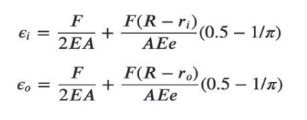Theoretical Stains for inner and outer strain gauges respectively:

* ri = 64.8 mm
* r0 = 50mm
* b = 11.2mm
* E = 70 GPa
* Area(A) = b(r0-ri) = 165.76 mm2
* Neutral axis(R)=(r0-ri)/(ln(r0/ri)) = 57.08057586 mm

**Observation Table:**

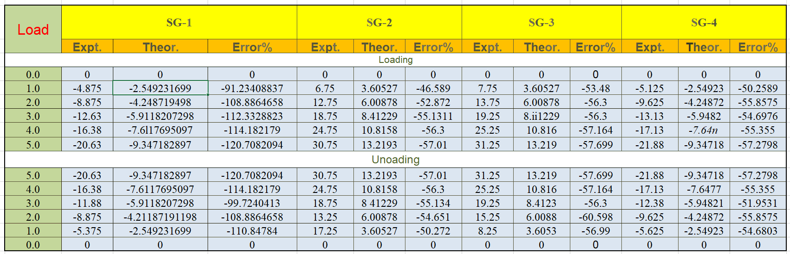



The plots for the values of the four strain gauges are as follows:

* Similar behavior of SG-1 and SG-4 (decreasing graph)

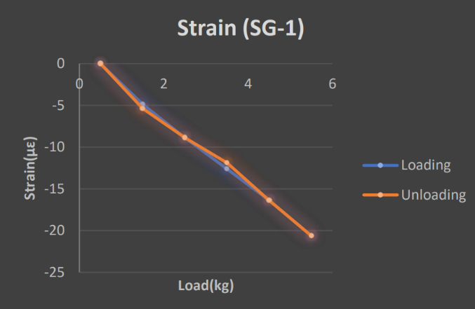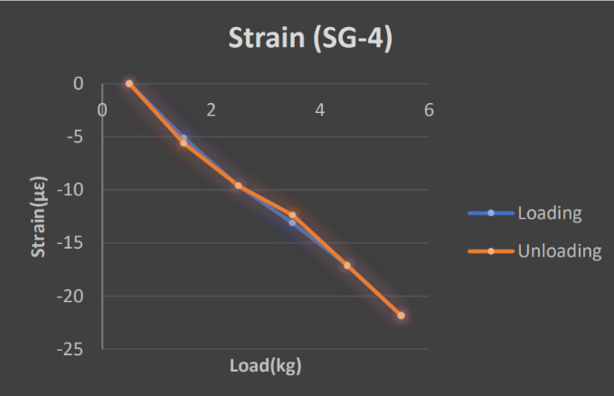

* 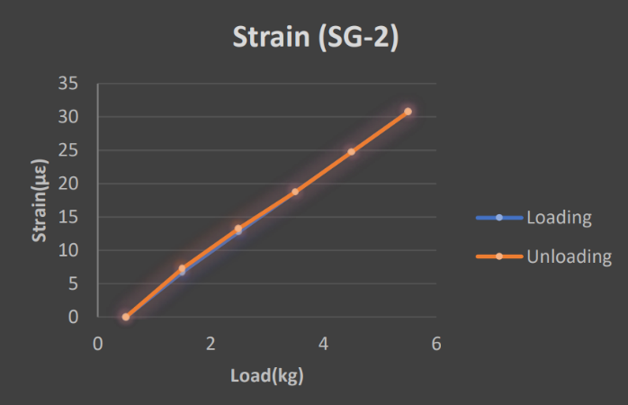Similar behavior of SG-2 and SG-4 (increasing graph)

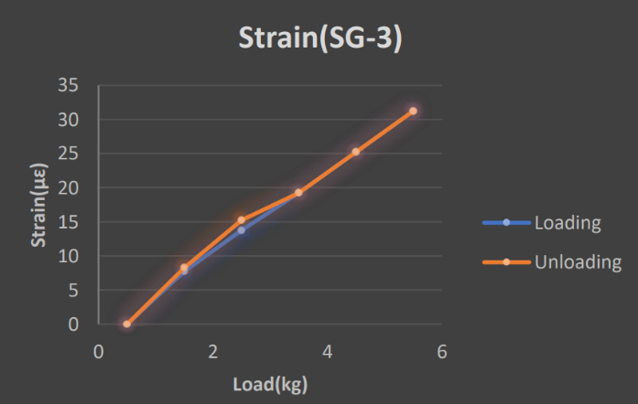

1. **Analysis/observations/discussion**
2. The almost linear strain versus load graph suggests that for smaller loads, Hooke's law is applied.
3. Percentage error for gauges on internal surface is much higher than outer gauges, this may be due to loose connections or some residual stresses.
4. As expected from theory the outer rings have compression while inner rings are in tension.
5. We observe the same strain values during loading and unloading to which we can comment that the specimen is within it’s elastic range
6. For S1 the experimental values were consistent with the theoretical values as in S1 percentage error is minimum of all others.
7. Even when there is no load attached, strain gauges show non-zero values which shows strains due to residual stresses and strains due to own weights.
8. **Summary/conclusions.**
9. We learn that the proving ring follows hooke’s law during loading and unloading
10. There have remained some residual stresses after unloading which has been reflected in the data as at zero load there were some strain present.
11. We observe that the outer ring has compression while inner ring has tension.
12. The strain is increasing in all four strain gauges with increasing load.
13. For the same value of load applied during loading and unloading the values of strain are almost equal which proves the symmetry of the ring and forces.
14. S1 has least error from literature values which shows the consistency from literature.
15. Also all the values are slightly higher from the literature values.
16. The inner ring is in tension and the outer ring is in compression.
    1. **Sources of error**:
17. Improper balancing of the entire experimental setup.
18. While putting the weights on the hanger, the center of gravity might be disturbed.
19. Temperature variation can cause some variation or error in the readings since we are working in the very small strain regime.
20. Loose and improper wires between the setup and strain gauge could cause error.
21. Parallax and least count error.